Growth Stages of Tomato Plant
Germination
Plant is still just a seed and has not fully developed any leaves. Germination lasts about 6-12 days.

Seedlings
Plant has penetrated past the soil and has developed two “seedling” leaves.

Vegatative
Plant has developed it’s “true” leaves. These are the first leaves grown after the seedling leaves and are unique to the plant species.

Flowering
The first flower buds appear on the plant. It is now okay to begin pruning.

Fruiting
The first fruits appear on the plant. In a greenhouse environment an indeterminant tomato plant will continue to fruit, and its main stem will continue to grow as long as the plant is kept healthy and properly maintained.

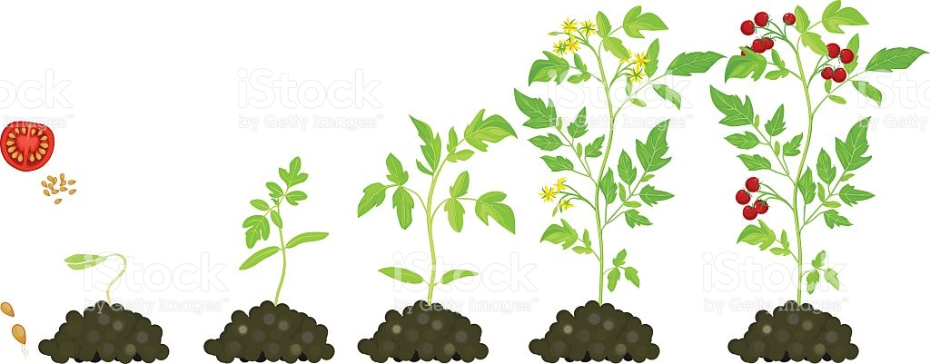

Seedling Vegatative Vegatative Flowering Fruiting

